Hospital Management System
Software Requirements Document
V 1.0


 | Prepared By | Reviewed by | Approved By
Name | Sagar S
Role | Team member | Project Leader/ Team Leader/ Team Member | Project Manager/ Team Leader
Signature | Sagar S
Date | 25`/11/2014

Table of Contents
Introduction 3
1.1 About this document 3
1.1.1 Purpose & Scope of the document 3
1.1.2 Intended Audience 3
1.2 About the Software System 3
1.2.1 Purpose 3
1.2.2 Scope of the system 4
1.2.3 Exclusions 4
1.2.4 System Perspective 5
1.2.5 System diagram 5
1.2.6 Architecture diagram 5
1.2.7 System Environment 7
1.2.8 User Characteristics 7
1.2.9 Impact of the System 7
1.2.10 Assumptions, Dependencies, Risks / Constraints 7
1.2.11 Design Constraints 8
System Requirements 9
1.3 Functional Requirements 9
1.3.1 Hospital Management System - Enroll Patient 9
1.3.2 Add Physician 11
1.3.3 Physician Search 13
1.3.4 Patient Diagnosis Details 14
1.3.5 View Patient History 16
1.4 Nonfunctional Requirements 17
1.4.1 UI Requirements: Inn 17
1.4.2 Performance Requirements: Pnn 17
1.4.3 Installation, Deployment & Operational Requirements: Onn 17
1.4.4 Maintainability & Portability Requirements: MPnn 18
1.4.5 Security Requirements Snn: 18
2.0 Requirements / Use Case Summary Table 18
Make /Buy analysis 19
2.1 Reusable components 19
Annexure 19
Change Log 19

Introduction

About this document

Purpose & Scope of the document
The purpose of the software requirements document is to systematically capture requirements for the project and the system Hospital Management System (HMS) application. HMS is a system used for managing the activities of a Hospital such as Enrolling a Patient, Patient Diagnosis Details, Case History of a Patient, Adding a Physician, Physician Search.
The scope of this document is limited to addressing the requirements from a user, quality, and non-functional perspective. It is recommended that design aspects are not added in this document

Intended Audience
Project Team

About the Software System
The client would like to develop an independent application Hospital Management System (HMS). The core essence for the system is to register a Patient into the system, to add/ save the Physician details, to search for Physician based on specified search criteria, Patient Diagnosis details and to View Patient History.
The following section will cover aspects related to Property Insurance Management System.

Purpose
The Hospital Management System (HMS) core essence for the system is to register a patient info, to add/ save the Physician details, to search for Physician based on specified search criteria, Patient Diagnosis details and to View Patient History.
The following are the important modules in the system
- Enroll Patient
- Add Physician
- Physician Search
- Patient Diagnosis Details
- View Patient History

Scope of the system
The scope of the system is explained through its modules as follows
  - Enroll Patient – Hospital Administrators to register a Patient into the system. The administrator should have the details of the patient to be entered into the system.
  - Add Physician - Hospital Administrators to save the Physician details into the system.
  - Physician Search - Hospital Administrators to search for Physician based on specified search criteria
  - Patient Diagnosis Details - by Hospital Administrators to save the patients diagnosis details into the system.
  - View Patient History - Administrator wishes to view the patient case history details

Use Case Diagram
The Hospital Management System

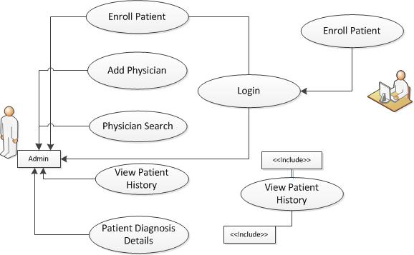

Exclusions
The system will operate only on the modules discussed above and will not include any additional functionality.

System Perspective
Hospital Management System is an independent software system developed to manage the activities like HMS Enroll Patient, Add Physician, Physician Search, Patient Diagnosis Details and View Patient History using the Java/ Dotnet architecture.

System diagram
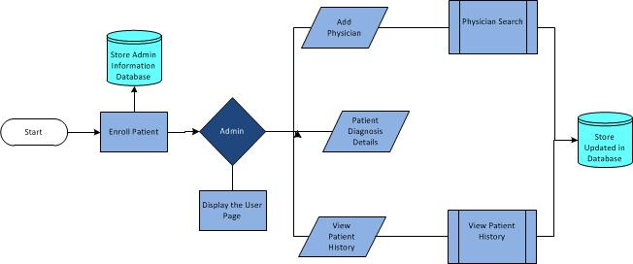

Architecture diagram

Physical Architecture:
A physical architecture is an arrangement of physical elements, (system elements and physical interfaces) that provides the designed solution for a product, service, or enterprise. It is intended to satisfy logical architecture elements and system requirements. Auto Identification Process follows a three layered architecture namely presentation layer, business logic layer and data access layer.
- Presentation Tier is the tier in which the users interact with an application. Presentation Tier contents Shared UI code, Code Behind and Designers used to represent information to user.
- Business Tier is mainly working as the bridge between Data Tier and Presentation Tier. All the Data passes through the Business Tier before passing to the presentation Tier. Business Tier is the sum of Business Logic Layer, Data Access Layer and Value Object and other components used to add business logic.
- Data Tier is basically the server which stores all the application’s data. Data tier contents Database Tables, XML Files and other means of storing Application Data.
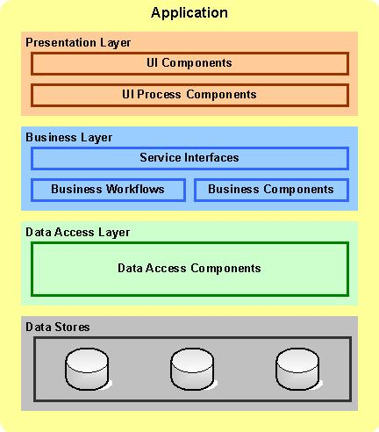

Logical Architecture:
The Logical Architecture defines the Processes (the activities and functions) that are required to provide the required User Services. Many different Processes must work together and share information to provide a User Service. The Processes can be implemented via software, hardware, or firmware. The Logical Architecture is independent of technologies and implementations
3-Layered Architecture Logical Diagram
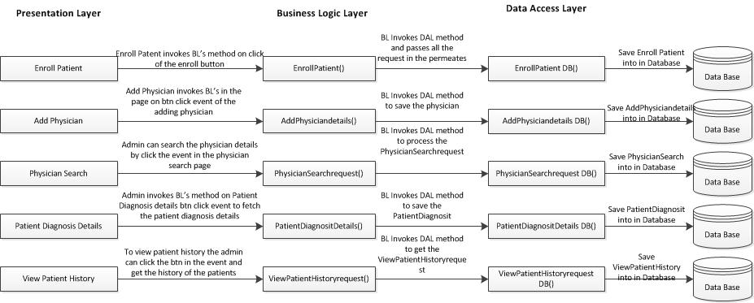

System Environment
The Hospital Management System application will be operated from the client server with parallel processor support. When a user connects to the Web Server, the Web Server will interact with the Database after processing the business logic to transfer data to and from a database.
- Java/J2EE or .NET Framework application deployment.
- My Sql/Sql server database for data storage

User Characteristics
The application should be user friendly; hence the user should not need any software and hardware knowledge. The user may be new to the client products having never used them before.
The types of users likely to use the system are as follows,
- Client
- Delivery Assurance Group, Process Engineering group
- Developers, testers, other associates in the project

Impact of the System
This is a new product which is developed for internal users. Expected impact of the product is to automate existing manual processes in order to make them more efficient and cost effective.

Assumptions, Dependencies, Risks / Constraints
Assumptions:
The HMS Admin must possess transaction data along with their patient’s inform and status for the entire enrolled patient in the hospital.
Dependencies:
If there is any similar Hospital management process required for other applications of the same client, this system should be able to accommodate such a reusability dependency.
Risks:
If there is any failure in Hospital management process, the system should be able to handle such a financial risk.

Design Constraints
Application should have single login feature. Login functionality should be the welcome feature for the application.
Only administrator can access the application.
None of the application features can be accessed without login.

System Requirements

Functional Requirements

Hospital Management System - Enroll Patient
Hospital Management System Req-2.1.1 | Creating Account
When the users enter the following link http://localhost:8080/ HospitalManagementSystem in the browser, Home page appears which will have a short welcome message; a brief introduction to the purpose of the Hospital Management System, the user can choose appropriate options.
Under home page, we need below interface and Home page Interface Requirements.

Enroll Patient form should have basic attributes/fields as mentioned in UI Interface Screen section.

At any given point of time, the user can Deselect/Reset all or can go to home page by the clicking home.
UI Interface Screen | First Name – Represents the First Name of the Patient.  Last Name - Represents the Last Name of the Patient.  Password - Represents the Password of the Patient  Date of Birth – Represents the Date of Birth of the Patient.  Email Address – Represents the Email Address of the Patient.  Contact Number - Represents the Contact Number of the Patient.  State – Represents the State of the Patient.  Insurance Plan – Represents the Insurance Plan of the Patient.
Trigger | Administrator triggers the functionality once he receives the details of the new patient.
Pre-Conditions | The administrator should have the data to be feed into the system.
Post Conditions | The data will be updated into the system and a unique id will be generated.
Success End Condition | Display the successful registration message with the generated unique id.
Failed End Condition | The system should display an error message if one of the validations is wrong.
Steps & Actions | - When the Enroll Patient selects the “Enroll Patient” option, the system should allow the below inputs from the user. Patient Id should be starting from 1000  - System needs to store the patient details into the system
Business Rules & Validations | - When first name / last name are entered with any character other than alphabet, system should display appropriate error message.  - Patient ID should be a unique id generated by the system.  - When date of birth is entered it should be valid date format (dd-mon-yy) and must not be greater than current date otherwise system should display appropriate error message.  - Email Id should be in a valid email format, otherwise the system should display an appropriate error message.  - Phone number field should allow only numbers to be entered. For an invalid entry the system should display an error message.  - If the First Name and Last Name already exists in the system, an appropriate error message must be displayed and the system should not allow the user to be enrolled twice.  - The State field should be pre-populated with values from the State table.  - The Plan field should be pre-populated with values from the Plan table.  - All fields are mandatory.

Add Physician
Hospital Management System Req-2.1.2 | Add Physician
The Administrator aadding the physician details the system.
The physician ID should be a unique id generated by the system. Physician Id is a combination of alphabets and numbers. First two characters of Physician Id should be PR followed by a three digit unique number starting from 001
UI Interface Screen | Physician First Name-Represents the First Name of the Physician.  Physician Last Name-Represents the Last Name of the Physician  Department – Represents the Department of the Physician  Educational qualification – Represents the Educational qualification of the Physician.  Years of Experience- Represents the Years of Experience of the Physician  State – Represents the State of the Physician.  Insurance Plan – Represents the Insurance Plan offered by the Physician.  Register- Register option to submit the details into the system.  Reset-reset all the fields for the Physician registration screen
Trigger | Administrator triggers the functionality once he receives the details of the new patient.
Pre-Conditions | Administrator should have the details of the physician
Post Conditions | The system will store the physician data in the database
Success End Condition | Newly added physician will be available in the system
Failed End Condition | The system should display an error message if one of the validations is wrong.
Steps & Actions | - System should display all the necessary fields  - System should save the details to database.  - Physician ID should be a unique id generated by the system. Physician Id is a combination of alphabets and numbers. First two characters of Physician Id should be PR followed by a three digit unique number starting from 001.
Business Rules & Validations | - When first name / last name are entered with any character other than alphabet, system should display appropriate error message.  - Department field should accept avalid department name from the admin.  - Educational qualification should allow only alphabets and space; otherwise the system should throw the appropriate error message.  - Years of experience should allow only Numeric values; otherwise the system should throw the appropriate error message.  - If the First Name and Last Name already exists in the system an appropriate error message must be thrown and the system should not allow the physician to be enrolled twice.  - The State field should be pre-populated with values from the State table.  - The Plan field should be pre-populated with values from the Plan table.  - All fields are mandatory.

Physician Search
Hospital Management System Req-2.1.3 | Physician Search
Administrators to search for Physician based on specified search criteria.

UI Interface Screen | - State – Represents the State of Physician  - Plan – Represents the Plan of Physician  - Department – Represents the Department of Physician  - Search option to enable the search criteria.  - Reset option to reset all fields
Trigger | Administrator selects the Physician Search option from home screen
Pre-Conditions / Assumptions | The system should display the search criteria on the screen
Post Conditions | The system will retrieve the search results
Success End Condition | The results matching the search criteria will be displayed
Failed End Condition | The system should display an error message if one of the validations is wrong.
Steps & Actions | - System should display the search criteria like Department Id, Department Name and State.  - Depending on the search criteria selected by the Administrator appropriate Physician details should be displayed.
Business Rules & Validations | All Search criteria are Mandatory.

Patient Diagnosis Details
Hospital Management System Req-2.1.4 | Patient Diagnosis Details
The patient diagnosis details will be stored along with the Physician details
UI Interface Screen | - Patient Id – Represents the Patient Id.  - Diagnosis Id - Represents the Diagnosis Id which is system generated.  - Symptoms – Represents the Symptoms of the Patient.  - Diagnosis Provided – Represents the Diagnosis Provided for the Patient.  - Administered by - Represents the Doctor who had visited the Patient.  - Date of Diagnosis – Represents the Date of Diagnosis of the Patient.  - Follow-up Required – Represents whether the Follow-up is requiredfor the Patient.  - Date of Follow up - Represents the Date of Follow up for the Patient.  - Bill Amount - Represents the Bill Amount of the Patient.  - Card Number - Represents the Card Numberof the Patient.  - Mode of payment - Represents the Mode of payment of the Patient.
Trigger | Once the patient is enrolled the administrator can enter the information pertaining to the health issues of the patient and the diagnosis provided
Pre-Conditions / Assumptions | The patient should be enrolled into the system
Post Conditions | The data will be updated into the system.
Success End Condition | Display the success message after the data is successfully saved in the database.
Failed End Condition | The system should display an error message if one of the validations is wrong.
Steps & Actions | - System should display all the necessary fields in the screen.  - System needs to store the patient details into the system
Business Rules & Validations | - The Symptoms and Diagnosis field should allow alphanumeric characters. System should display an alert message if special characters are entered.  - Physician list should be displayed based on the state and plan of the patient selected in the Patient Diagnosis Details screen.  - Date of Diagnosis should be a valid date format (dd-mon-yy) and must not be greater than current date otherwise system should display appropriate error message.  - Date of Follow-up should be enabled only if the patient has been marked for follow-up.  - Follow-up date should be a valid date format (dd-mon-yy) and it should be a future date, otherwise the system should display an error message.  - The Billing section should be enabled only after the diagnosis details are saved in database.  - The State field should be pre-populated with values from the State table.  - The Plan field should be pre-populated with values from the Plan table.  - All fields are mandatory.

View Patient History
Hospital Management System Req-2.1.5 | View Patient History
The View Patient History tab will shows all the history of the patient case with along with
Physician Details
UI Interface Screen | - Patient Id - Represents the Patient Id of the Patient.  - First Name – Represents the First Name of the Patient.  - Last Name - Represents the Last Name of the Patient.
Trigger | Administrator wishes to view the patient case history details.
Pre-Conditions / Assumptions | Physician should be enrolled into the system.  The patient should be enrolled into the system.
Post Conditions | The system will retrieve the data based on the search criteria
Success End Condition | View records matching the entered search criteria.
Failed End Condition | The system should display an error message if one of the validations is wrong. The validation and business rules are mentioned in the business rules section.
Steps & Actions | Registered user should login to the system and select the option ‘To find an agent online’. And also need provide the Location details and system should display all the necessary field details.
Business Rules & Validations | - Either Patient ID or the combination of First Name Last Name should be entered else system should mandate the user to enter any one of this.  - Symptoms in the View Patient History screen should be displayed for the entered Patient Id or Patient Name and on selecting a particular symptom for a Patient, complete details like Diagnosis, Physician list, Date of Diagnosis, Date of Follow-up, Follow-up date, Bill Amount etc. should be displayed.

Nonfunctional Requirements

UI Requirements: Inn
- The front end should be user-friendly and pleasant
- Any error message or exception displayed to the user should be user-readable (and not technical)
- All entered values should be validated
- The UI screens are designed with any theme color along with the logo of the company.
- Exceptions should not be shown on console.
- No debug message should come on console.
- All the errors and exceptions should be logged to log file.
- Log file path should be configurable.
- Database connections should be configurable.
- It should not be hard coded.
- Requirements involving UI features should be taken care in console accordingly

Performance Requirements: Pnn
- All front-end pages should be served up in less than 5 seconds post click when up to 1000 users are on the application concurrently.
- Since it’s a financial operations application, transactions should be safe and fast.

Installation, Deployment & Operational Requirements: Onn
- Application Java and J2EE deployment with My SQL database or SQL Server database for persistence
Or
Application .NET Framework deployment with SQL Server database for persistence
- This system must be up 24X7

Maintainability & Portability Requirements: MPnn
- If the allocated memory space for the existing application needs to be increased then it should be possible without any impact to performance

Security Requirements Snn:
- No unauthorized users should be able to log on to the system
- User Id/Login Id should have combination of letter and numeric values, none of the special characters are allowed (#,@,$,%,&).
- Validate the user id/login id and password, accordingly to the user it will redirect to the appropriate page.

Requirements / Use Case Summary Table
Business Requirement ID | Software Requirements ID | Short Description | Requirement Provider (Originator) | Priority | Complexity | Requirement type | Remarks
BR001 | SR001 | Enroll Patient | Client | High | Medium | UI screen & backend processing | -
BR002 | SR002 | Add Physician | Client | Medium | Medium | UI screen & backend processing | -
BR003 | SR003 | Physician Search | Client | High | Medium | UI screen & backend processing | -
BR004 | SR004 | Patient Diagnosis Details | Client | Medium | Medium | UI screen & backend processing | -
BR005 | SR005 | View Patient History | Client | High | High | UI screen & backend processing | -

Make /Buy analysis

Reusable components
The HMS can be made reusable as such to handle various Hospital Management System.

Annexure
NA

Change Log
Please note that this table needs to be maintained even if a Configuration Management tool is used.
Version Number | Changes made
V1.0 | First version developed by Sagar S on Nov 21 2014.
V1.1 | <If the change details are not explicitly documented in the table below, reference should be provided here>
V1.1 | Page no | Changed by | Effective date | Changes effected
V1.2 | <If the change details are not explicitly documented in the table below, reference should be provided here>
V1.2 | Page no | Changed by | Effective date | Changes effected

